

CREATING A DEPLOYMENT
DevOps Certification Training

support@intellipaat.com
+91-7022374614
US: 1-800-216-8930(Toll Free)

CREATING A DEPLOYMENT
Steps for Master

Step 1: Create a file, nginx.yaml and enter the following code
apiVersion: apps/v1
kind: Deployment
metadata:
name: nginx-deployment
labels:
app: nginx
spec:
replicas: 3
selector:
matchLabels:
app: nginx
template:
metadata:
labels:
app: nginx
spec:
containers:
- name: nginx
image: nginx:1.7.9
ports:
- containerPort: 80

Step 2: Create the deployment using the following command:
$ kubectl create –f nginx.yaml

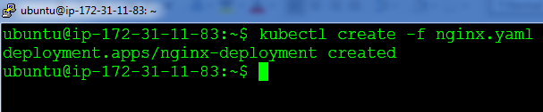

Step 3: Verify the procedure, by listing the pods:
$ kubectl get po

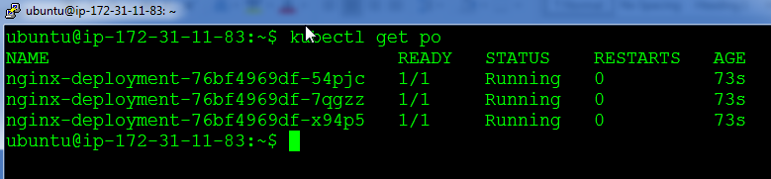

You have successfully deployed nginx on Kubernetes!!

